**Team 3**

**Delivered ✅**

**Software Design Report for Online**

**Restaurant System**

**Version 2.0**

Chrystal Mingo

Marina Skachko

Maya Dara Sofia Pasiliao

Mayra Vazquez-Sanchez

**Revision History**

|  |  |  |  |
| --- | --- | --- | --- |
| **Date** | **Version** | **Description** | **Author** |
| 11/04/2019 | 1.0 | Initial plan | Team 3 |
| 11/27/2019 | 2.0 | Design Plan for online restaurant system | Team 3 |
|  |  |  |  |
|  |  |  |  |

**Table of Contents**

1. Introduction 4

2. Use-Cases 4

3. Entity Relation Diagram 4

4. Detailed Design 5

5. System Screens 12

6. Meeting Minutes 35

7. GitHub Repository 36

**Software Design Report**

# Introduction

# The purpose of this report is to delineate the data structure and logic that will implement the features described in the specification report for *Delivered* ✅. This report outlines the system through a collaboration class diagram. It then proceeds to describe all use-cases with collaboration class and petri-net diagrams. The system is then portrayed with an E-R diagram followed by pseudocode for every method. System screens can also be found which show the major GUI screens. Finally, we provide information about the workings of our group along with the GitHub repo for our project. The next page contains a collaboration diagram for the system.

# Use-Cases

# 2.1 Login/ Logout

# All users are first shown the log-in screen. If no username and password is provided, user is asked if they want to register. If a user logs in with a username and password, they are redirected to the registered customer page.

# 

# 

# 

# 2.2 Register

# A visiting customer is always given the choice to register, although registration must be approved by manager. Before a pending registration is submitted, visitor's registration info is checked against the Blacklist DB. If visitor is blacklisted, their registration is automatically declined.

# 

# 

# 2.3 Place Order

# Visitors, registered customers, and VIP customers can place orders. VIP customers receive discounted prices and additional food items for free. Registered customers receive discounted prices. Visitors do not receive benefits. If due to extraneous circumstances the order is not saved, the status will be shown to customer.

# 

# 

# 2.4 Rate Food/Cook/Delivery Person

# Visitors are not allowed to rate food, cook, or delivery person. Registered customers and VIP members input their ratings in Customer UI, which is then stored in Ratings DB. Status of success or fail is returned to customer when saving succeeds or fails due to extraneous circumstances.

# 

# 

# 2.5 Bid on Deliveries

# When an order is placed, managers initiate a bidding process for delivery people. Delivery person with lowest asking price wins. The winning delivery person is then stored in Orders DB in the row of the order they won. Status of success or fail will be returned to delivery person if save failed.

# 

# 

# 2.6 Choose Optimal Delivery Route

# Delivery person's current location and customer address from the Orders DB is input into an API to calculate optimal route. In diagram API is called Optimal Route Manager. Optimal route is then displayed to delivery person. This requires internet connection.

# 

# 

# 2.7 Rate Customers

# Delivery people can rate customers after delivery. This rating is stored in the Ratings DB with ratings for food, cooks, and delivery people. Status of success or fail is returned to customer when saving succeeds or fails due to extraneous circumstances.

# 

# 

# 2.8 Decide Pay for Cooks/Delivery people

# A rating by customer that is less than 3 is considered a complaint. If a delivery person receives an average rating of less than 2 for their last 3 deliveries will be warned. If delivery person receives an average rating greater than 4 for last 3 deliveries, they will get a raise. Warnings can be overridden by a manager. A cook whose food was dropped twice will receive a warning. A cook with more than 3 warnings will be fired. Warnings and salaries are stored in the Ratings DB. Pay Manager contains all functions and conditions to determine whether an employee should be fired or receive a raise. Status of success or fail is returned to manager when saving succeeds or fails due to extraneous circumstances.

# 

# 

# 2.9 Approve/Decline New Customers

# Managers can approve pending customer registrations. Registrations from customers on the blacklist are automatically denied (shown in Registration diagrams). If manager declines a registration, customer is notified and their pending registration is deleted from Accounts DB. If manager approves a registration, pending status is removed and visitor is then a registered customer in Accounts DB.

# 

# 

# 2.10 Handle Complaints

# Manager selects an employee from Accounts DB that has complaint to handle. A rating by customer that is less than 3 is considered a complaint. If a delivery person receives an average rating of less than 2 for their last 3 deliveries will be warned. Warnings can be overridden by a manager. Status of success or fail is returned to manager when saving succeeds or fails due to extraneous circumstances.

# 

# 

# 2.11 Decide Commission for Salespeople

# Manager selects a salesperson from Accounts DB. Salesperson who has received 3 straight 5s will receive a 10% raise. If they have received a complaint 3 times, they receive a warning and their commission is reduced by 10%. 3 warnings will cause them to be fired.

# 

# 

# 2.12 Determine Menu

# Cooks are able to edit menu. Changes are submitted to the Menu Manager, which requests information from Menu DB. Status of success or fail is returned to cook when saving succeeds or fails due to extraneous circumstances.

# 

# 

# 2.13 Determine Food Prices

# Cooks are able to determine food prices. Changes are submitted to the Menu Manager, which requests information from Menu DB. Status of success or fail is returned to cook when saving succeeds or fails due to extraneous circumstances.

# 

# 

# 2.14 Determine Quality of Supplies

# Cooks are able to determine quality of supplies. Changes are submitted to the Ratings Manager, which requests information from Ratings DB. Status of success or fail is returned to cook when saving succeeds or fails due to extraneous circumstances.

# 

# 

# 

# Entity Relation Diagram

In this diagram, keys are bolded and underscored. Some attributes were skipped because of the space constraints.

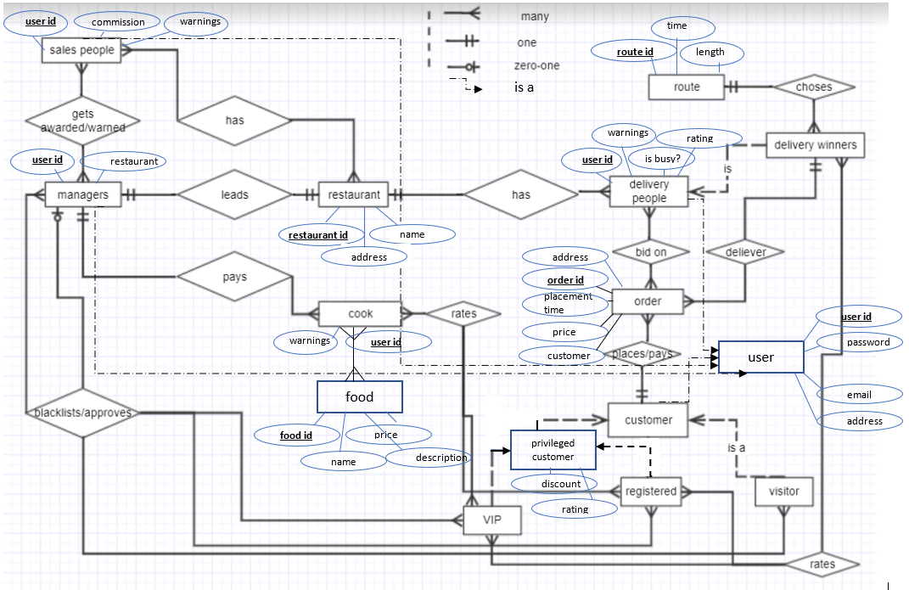

# Detailed Design

Following is a list of functions and their pseudocodes, which we will implement in our project.

**All users’ functionality**

***// function to check if user with this username exists***

***// Takes string username***

***// Returns name of text file where user exists if username already exists, empty string otherwise***

***function is_user_exist(username) {***

***file = open_file("customers_data.txt");***

***if (username_found) {***

***return "customers_data.txt";***

***}***

***file = open_file("delivery_people_data.txt");***

***if (username_found) {***

***return "delivery_people_data.txt";***

***}***

***file = open_file("salespeople_data.txt");***

***if (username_found) {***

***return "salespeople_data.txt";***

***}***

***return "";***

***}***

***// function which checks if user with given name is on blacklist***

***// input - string fullname***

***// output - true if full name was found in one of blacklists,***

***// false otherwise***

***function is_blacklisted(fullname) {***

***file = open_file("customers_blacklist.txt");***

***if (username_found) {***

***return true;***

***}***

***file = open_file("delivery_people_blacklist.txt");***

***if (username_found) {***

***return true;***

***}***

***return false;***

***}***

***// login function. Takes strings password and username, user_type***

***// returns true if user exists and password matches in a user_type file,***

***// otherwise returns false***

***function authenticate_user(username, password) {***

***var user_data_file = is_user_exists(username);***

***if (user_data_file != "" && username.password == password) {***

***return true;***

***} else {***

***print("incorrect username or password. Please try again");***

***return false;***

***}***

***}***

***// function to register a new user.***

***// Takes strings user_type (customer/delivery/salesperson) username, full_name, password, email,***

***//address, phonenumber***

***// Adds input strings to "pending_users" file if user doesn't already exists. Returns otherwise***

***function add_user(user_type, full_name, username, password, email, address, phonenumber) {***

***blacklist_file = open_file("customers_blacklist_file.txt");***

***if (is_blacklisted(fullname)) {***

***print("You cannot register at this moment. Please contact manager for more information");***

***return;***

***}***

***file = open_file(user_type + ".txt");***

***if (is_user_exists(username) != "") {***

***print("User with this username already exists");***

***return;***

***} else {***

***append_to_file(pending_users_file, username, password, email, address, phonenumber);***

***print("Your account is pending. We will send you an update soon!"***

**Customer’s functionality**

***//function which shows eligibility of customer to rate or get discount***

***// input: string customer_type***

***// returns true if eligible to rate, false otherwise***

***if (is_eligible_for_rate_discount(customer_type)) {***

***if (customer_type == "visitor")***

***return false;***

***else***

***return true;***

***}***

***// function which updates status of customers***

***// input string username***

***// result: A registered customer who made more than 3 orders with average rating >4 is***

***// automatically change_status to a VIP; a registered customer making more than 3 orders with***

***// average rating <2 but >1 is demoted to a visitor, if average rating is 1 then the customer***

***// is put in the customer blacklist***

***function customer_status_update(username) {***

***if (username.customer_type == "registered" && username.number_of_orders > 3) {***

***if (username.rating <= 1) {***

***change_status("registered", "customer_blacklist");***

***} else if (username.rating < 2) {***

***change_status("registered", "visitor");***

***} else if (username.rating > 4) {***

***change_status("registered", "VIP");***

***}***

***}***

***}***

***// function which changes status of customers***

***// input: string old_status, string new_status, string username***

***// result: textfiles are updated according to new statuses***

***function change_status(old_status, new_status, username) {***

***source = open(old_status + ".txt");***

***user = find(source, username); // get object with current username***

***user.customer_type = new_status;***

***remove(source, user);***

***write_to = open(new_status + ".txt");***

***write(write_to, user);***

***}***

***// function to get food rating from customers***

***// no input***

***// returns list of tuples food_rating_list {string food_item, float rating, string explanation} from customer's order***

***function get_food_rating() {***

***for (var line in html_form) {***

***var rating = read(line);***

***if (rating < 3) {***

***explanation = ask_for_explanation;***

***food_rating_list.append({ line.food_item, line.rating, line.explanation });***

***}***

***}***

***return food_rating_list;***

***}***

***// function which updates food rating. It is called every time a customer rates food from his/her order***

***// input: list of tuples food_rating_list {string food_item, float rating, explanation} from customer's order,***

***// string customer_type (privileged or not_privileged)***

***// result: changes food_item rating in food_rating_file***

***function update_food_rating(food_rating_list, customer_type) {***

***if (is_eligible_to_rate(customer_type)) {***

***file = open(customer_type + "_food_rating.txt");***

***for (food_item in food_rating_list) {***

***var old_record = find(food_item, file);***

***new_rating = old_record.rating + (food_item.rating - old_record.rating) /***

***(old_record.count + 1);***

***write(file, old_record, new_rating);***

***}***

***}***

***}***

***// function which updates delivery_person rating.***

***// input: pair delivery_person_rating {string delivery_person, float rating}***

***// result: changes delivery_person rating in delivery_people_data, if rating < 2 add 1 to strike of bad ratings.Otherwise zeros strike***

***function update_delivery_people_rating(delivery_person_rating) {***

***if (is_eligible_to_rate(customer_type)) {***

***file = open("delivery_people_data.txt");***

***var old_record = find(delivery_person_rating.delivery_person, file);***

***if (rating < 2) {***

***old_record.strike++;***

***} else {***

***old_record.strike = 0;***

***}***

***new_rating = old_record.rating + (delivery_person_rating.rating - old_record.rating) /***

***(old_record.count + 1);***

***write(file, old_record, new_rating);***

***}***

***}***

***// function which returns 3 most popular food_items based on order history***

***// input: string cutomer_type (privileged or not_privileged).***

***// returns array of 3 strings. IF privileged -  3 most relevant food choices based on the order***

***//history of the registered customers and VIPs. If not_privileged - same but for visitors.***

***function get_most_popular_food(customer_type) {***

***file = open(customer_type + "_food_rating.txt");***

***//sort file by food rating***

***sort(file);***

***var most_popular_food = [];***

***for (var i = 0; i < 2; i++) {***

***most_popular_food[i] = readline(file).item_name;***

***}***

***return most_popular_food;***

***}***

***//function which places order in system***

***// input: string customer_name, list food, float price, string address, bool payment***

***// returns object Order***

***function order_food(order_id, customer, location, time_of_placement, menu_items, price, is_paid) {***

***return new Order(order_id, customer, location, time_of_placement, menu_items, price, is_paid);***

***}***

**Manager’s functionality**

***// function for a manager to approve or deny customers in "pending_registration" file***

***// no input***

***// reads info from pending_customers file, reads manager's decision,***

***function resolve_pending_customers() {***

***file = open("pending_customers_file");***

***if (empty(file)) {***

***print("No pending customers");***

***} else {***

***//read pending customers line by line***

***while (!eof()) {***

***var customer = Read(pending_customer_from_html);***

***var decision = Read(manager_decision_from_html);***

***// here manager will check customer's record***

***if (decision == "Accept") {***

***append_to_file(customers_data, customer);***

***}***

***remove_from_pending_file(user);***

***}***

***}***

***}***

***// function which updates prices for customers considering their status (vip, registered, visitors)***

***// input: float original_price, string customer_type***

***// returns float updated_price***

***function get_price_with_discount(original_price, customer_type) {***

***var discount = 0.1;***

***if (!is_eligible_for_rate_discount(customer_type)) {***

***return original_price;***

***} else {***

***return original_price * (1 - discount);***

***}***

***}***

***// function which checks customer's eligibility for free food_items (VIP)***

***// input: string customer_type***

***// returns true if VIP, false otherwise***

***function is_eligible_for_free_items(customer_type) {***

***if (customer_type == "VIP")***

***return true;***

***else***

***return false;***

***}***

***// A delivery person receiving average rating <2 for the last 3 deliveries will receive a warning***

***// function to check if delivery_person has a strike of 3 consecutive ratings<2***

***// input: delivery_person***

***function is_warning(delivery_person) {***

***if (delivery_person.strike >= 3) {***

***delivery_person.warning++;***

***}***

***}***

***// function to check if delivery_person/cook/sales_person have more than 3 warnings, then they are laid-off***

***//input: string person***

***// output: true if laid_off, false otherwise***

***function is_laid_off(person) {***

***if (person.warning > 3)***

***return true;***

***return false;***

***}***

***//function to erase warning***

***function erase_warning(person) {***

***if (person.warning > 1) {***

***person.warning--;***

***}***

***update(file);***

***}***

***//function which increases sales person's payment***

***function increase_salesperson_comission(username) {***

***if (username.strike >= 3) {***

***username.comission *= 1.1;***

***}***

***}***

***function decrease_salesperson_comission(username) {***

***if (username.complains >= 3) {***

***username.comission *= 0.9;***

***}***

***}***

**Delivery People’s functionality**

***// function to read bids from html forms***

***function getBid() {***

***var myNewBidAmount = document.getElementById("myNewBid").value;***

***var myNewBid = new Bid(self.user_id, myNewBidAmount);***

***//updateWinningBid(order, myNewBid);***

***document.getElementById("myCurrentBid").innerHTML = myNewBidAmount;***

***//document.getElementById("currentWinningBid").innerHTML = order.winning_bid;***

***//function to update winning bid***

***function updateWinningBid(order, new_bid) {***

***if (order.winning_bid.amount < new_bid.amount) {***

***order.winning_bid = new_bid;***

***}***

***}***

***//update winners***

***function updateBiddingWinners(bidding_winners, order, winning_bid) {***

***bidding_winners.set(order, winnin_bid);***

***}***

***// delivery person rates customer***

***function delivery_rates_customer(username, customer_type, new_rating) {***

***if (customer_already_rated)***

***return;***

***else {***

***file = open(customer_type + ".txt");***

***var old_record = find(username, file);***

***new_rating = old_record.rating + (new_rating - old_record.rating) /***

***(old_record.count + 1);***

***write(file, old_record, new_rating);***

***}***

***}***

**Best Route functionality**

***//Init the geocoder library, array to hold the geo address***

***var geocoder = new google.maps.Geocoder();***

***var geoAddress = [];***

***//function framework***

***bytutorialMap = {***

***initNavigateMap: function (mapID, panelDirectionID, startLatitude, startLongitude, endLatitude, endLongitude) {***

***var directionsDisplay = new google.maps.DirectionsRenderer;***

***var directionsService = new google.maps.DirectionsService;***

***//initialize the map***

***var map = new google.maps.Map(document.getElementById(mapID), {***

***zoom: 7,***

***center: { lat: startLatitude, lng: startLongitude }***

***});***

***//clear the direction panel***

***$("#" + panelDirectionID).html("");***

***directionsDisplay.setMap(map);***

***directionsDisplay.setPanel(document.getElementById(panelDirectionID));***

***//prepare the latitude and longitude data***

***start = startLatitude + ", " + startLongitude;***

***end = endLatitude + ", " + endLongitude;***

***bytutorialMap.calculateAndDisplayRoute(directionsService, directionsDisplay, start, end);***

***},***

***//function to get the driving route***

***calculateAndDisplayRoute: function (directionsService, directionsDisplay, start, end) {***

***directionsService.route({***

***origin: start,***

***destination: end,***

***travelMode: 'DRIVING'***

***}, function (response, status) {***

***if (status === 'OK') {***

***directionsDisplay.setDirections(response);***

***} else {***

***alert('Directions request failed due to ' + status);***

***}***

***});***

***},***

***//get geolocation based on address***

***codeAddress: function (address) {***

***return new Promise(function (resolve, reject) {***

***geocoder.geocode({ 'address': address }, function (results, status) {***

***if (status == google.maps.GeocoderStatus.OK) {***

***resolve(results);***

***} else {***

***reject(Error("Geocode for address " + address + " was not successful for the following reason: " + status));***

***}***

***});***

***});***

***},***

***//function to get geolocation of both addresses.***

***getGeolocationData: function () {***

***if ($("#txtStartingPoint").val() != "" && $("#txtDestinationPoint").val() != "") {***

***geoAddress = [];***

***bytutorialMap.codeAddress($("#txtStartingPoint").val()).then(function (response) {***

***var geoData = {***

***latitude: response[0].geometry.location.lat(),***

***longitude: response[0].geometry.location.lng()***

***}***

***geoAddress.push(geoData);***

***}).then(function () {***

***return bytutorialMap.codeAddress($("#txtDestinationPoint").val()).then(function (response) {***

***var geoData2 = {***

***latitude: response[0].geometry.location.lat(),***

***longitude: response[0].geometry.location.lng()***

***}***

***geoAddress.push(geoData2);***

***});***

***}).then(function () {***

***bytutorialMap.initNavigateMap("map", "panel-direction", geoAddress[0].latitude, geoAddress[0].longitude, geoAddress[1].latitude, geoAddress[1].longitude);***

***});***

***} else {***

***alert("Please enter both addresses");***

***}***

***},***

***//clear entries and map display***

***clearEntries: function () {***

***$("#txtStartingPoint, #txtDestinationPoint").val("");***

***$("#map, #panel-direction").html("");***

***}***

***}***

***// we didn't consider voice-based functionality yet***

***// Also, methods for salespeople and cooks are to be added***

# System Screens

We created theuser-interface prototype for each user:  Customers (Visitors, VIP, Registered), Managers, Cooks, Salespeople, and Delivery people. We used the platform ***figma***to create these prototypes. The prototypes are used as a basis to help develop page to page what each user will experience on *Delivered* **✅,** our online restaurant delivery app. These are all rough drafts but have helped us consolidate how many pages we need to create and think about the user’s experience overall. Having the user-interface prototypehelped tremendously when it came to the execution of creating each page for the users, we implemented our WebApp *Delivered* ✅, using***HTML, CSS, and JavaScript****.*

**Home Page & Login/Registration Page:**

(Images of Prototype)

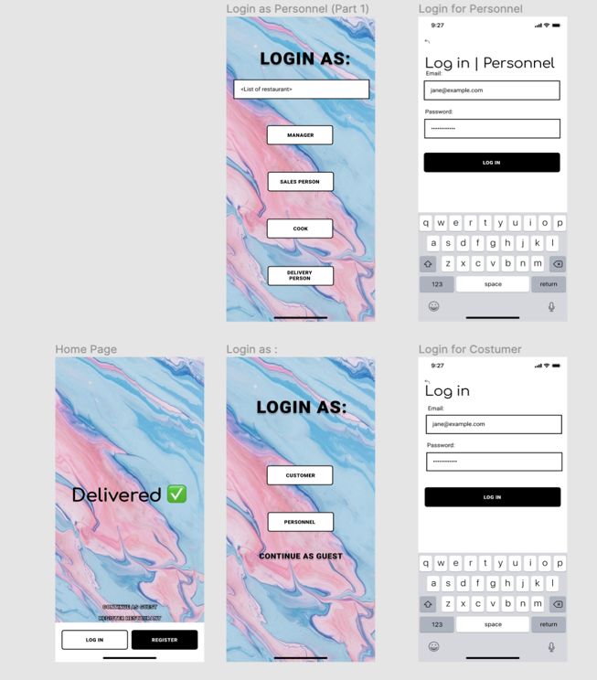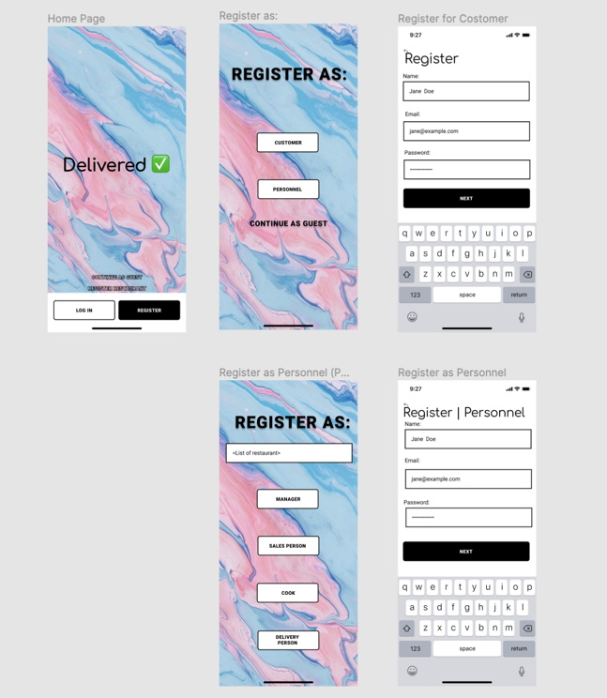

**Home Page of *Delivered* ✅:**

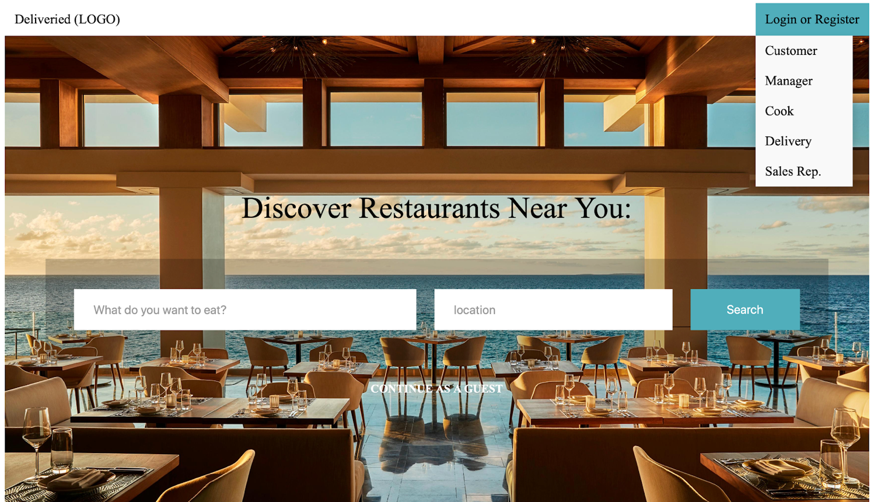

If you *scroll up* the nav bar will disappear and make the search bar the main focal point of the website

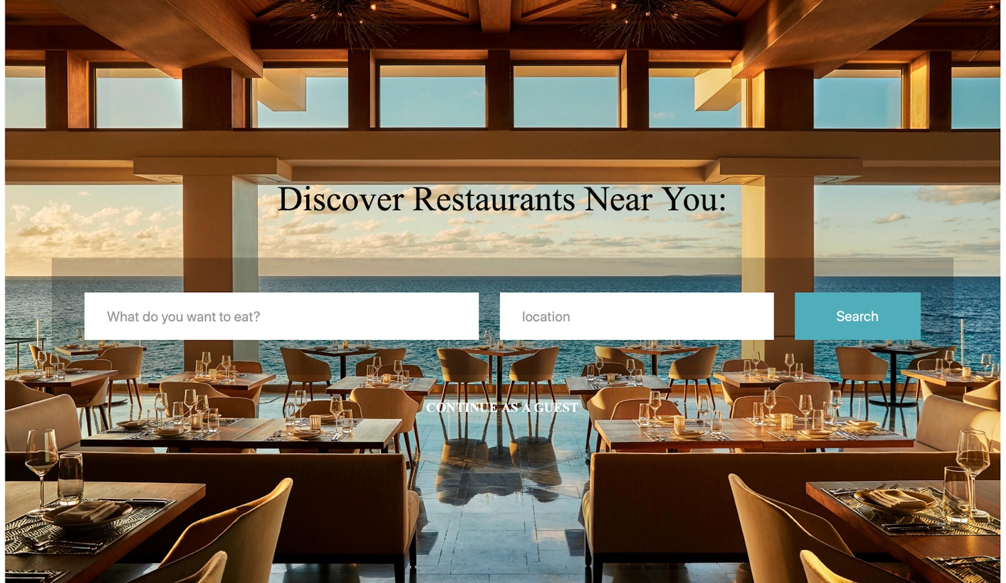

This is the home page of *Delivered* ✅, in this page you can find the *search bar* that allows the user to search for food depending on location. When you first go to the page when you hover over the “Login or Register” button, a drop-down menu appears showcasing all the users of the page: Customer, Manager, Cook, Delivery, and Sales Rep. Each user is linked to their own sign in or sign up page. Also, if you look at the bottom of the search bar it has “Continue as Guest” when you hover over the word it becomes much brighter and from there you are linked to the customer pages.

**Sign In & Sign Up pages**:

The sign in and sign up pages for all the users are quite similar using *Delivered* ✅, iconic teal blue. The major difference between all of them is the background behind the login and sign up because we wanted the pages to resonate with each user.

**Customer:**

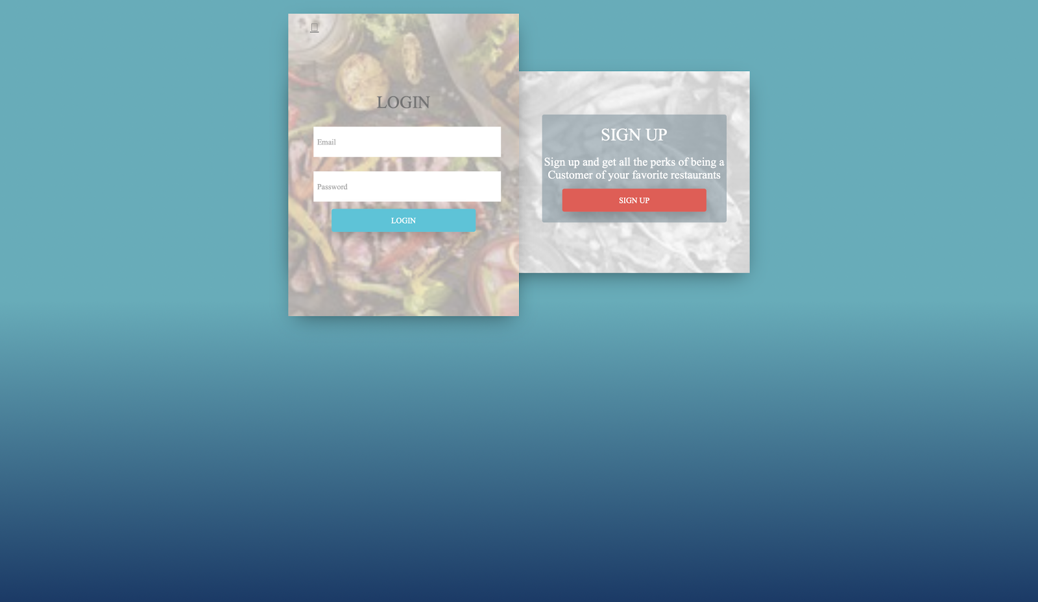

For the customer’s login/registration instead of doing single pages like we did in the prototype. We cut down the number of pages we needed to create and allowed the user to be able to access the sign in or up throughone page.

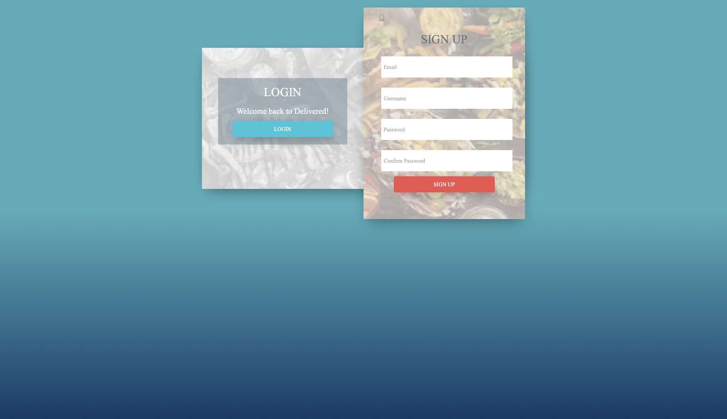

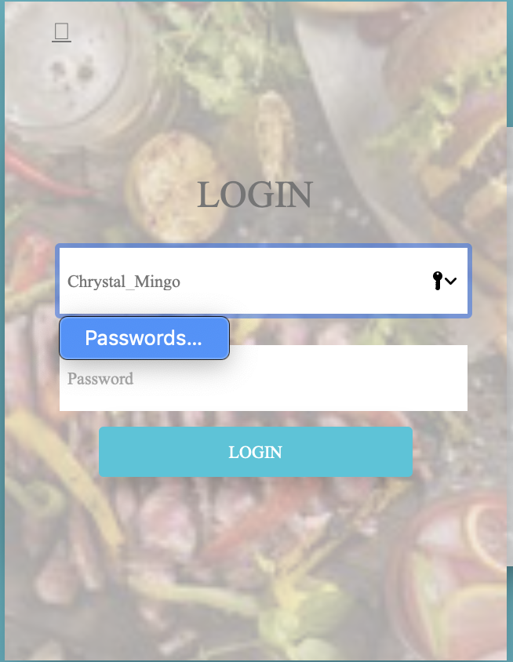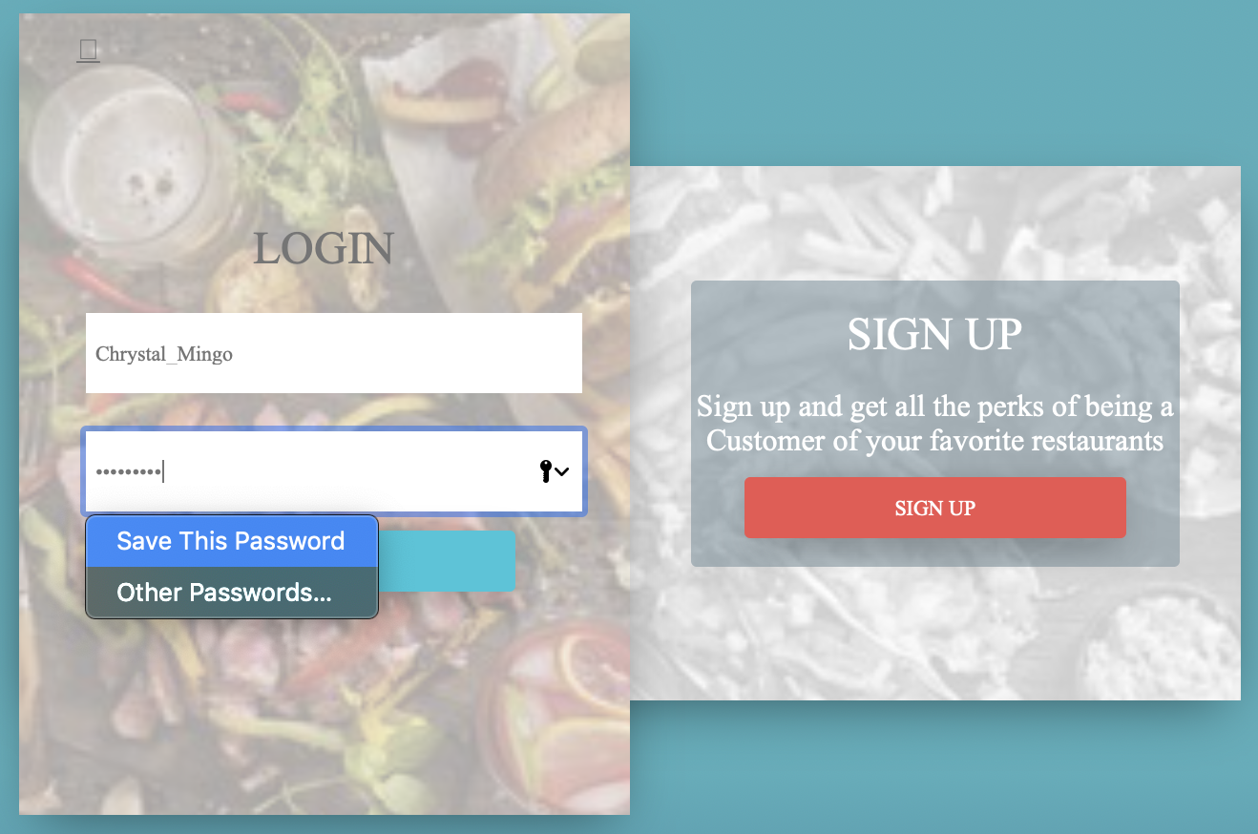

We programmed the login to save the user’s password and username, as well to showcase other passwords saved on the device they are using. If *Delivered* ✅  is saved on the list of passwords, it makes it easier and faster for the user to login. This is done with the click of one button, in this case it’s the key symbol with the downward arrow. (This functionality is the same for all users’ sign in of *Delivered* ✅)

When you click on the login button from the Customer’s Login page it will transition to the

***Delivered* ✅ platform for Customers:**

This is just the prototype for Customer, this page will have a chatbot, we will be using the *Google Dialog API*, which will help the customers order their food, and even give them ideas! In addition, we will allow the user to use voice recognition to order their food in the search bar, making it easy for customers to order food without having to type. The customer platform has multiple pages. Starting off with the discover page which showcases trendy restaurants nearby and displaying their cuisines. As you scroll down you see our “Food Heaven” this showcases delicious foods and when you hover over them you are able to see the restaurant that made the cuisine as well as the price. You can also view the full menu of the restaurant. The customers who are registered/VIP can post their food and give reviews on the food, cook, and delivery. They can also search for restaurants nearby, specific cuisines, and prices. They can order food by adding it to their cart and checkout and pay for their order online. A cool feature that we added is that the customer can see their order’s progress. For example, when it's cooking, being delivered, and so on. In order to implement these pages for the Customer, we will be using HTML, CSS, and JavaScript. Also, for special functionalities we will be using Google APIs such as Dialog, and Twilio or AWS for voice recognition.

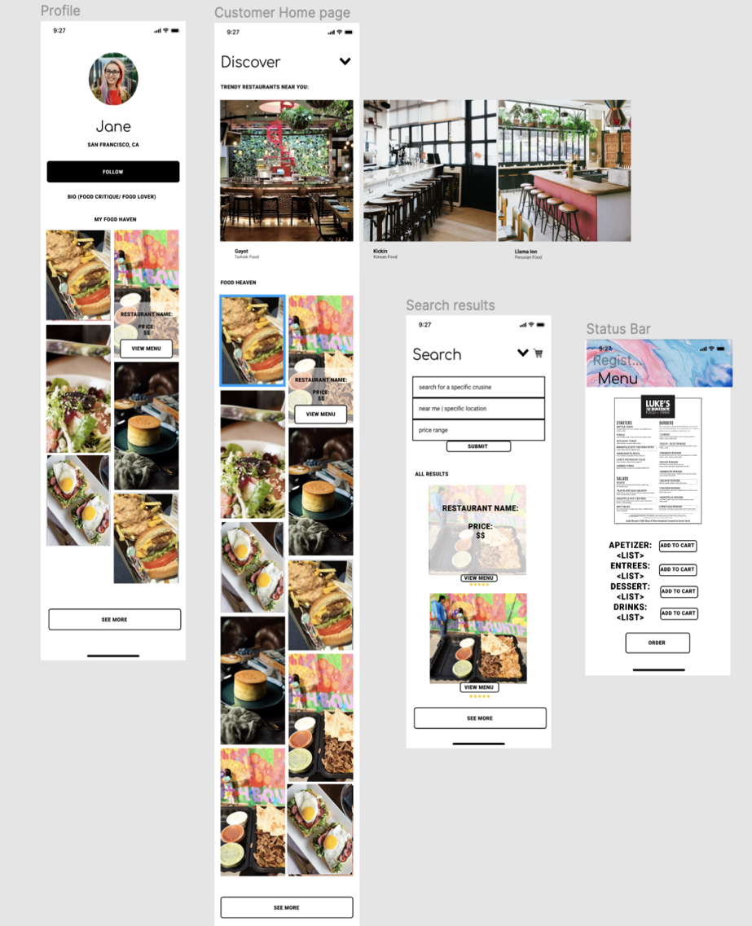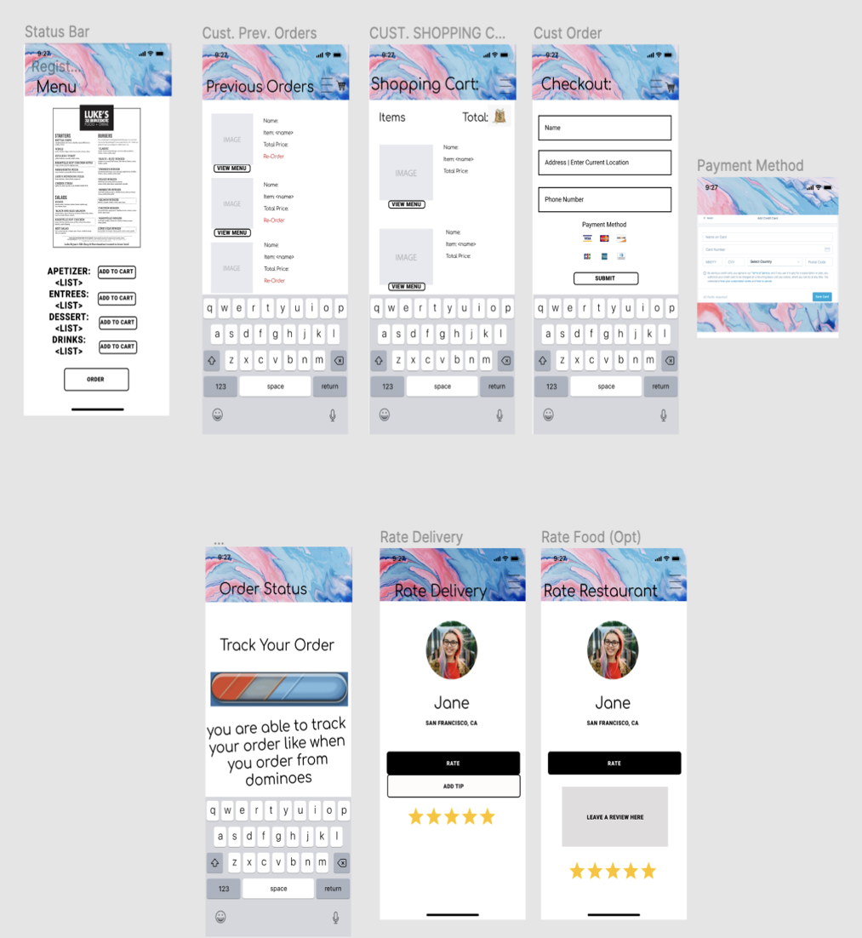

**Manager**:

(Sign In/ Up page)

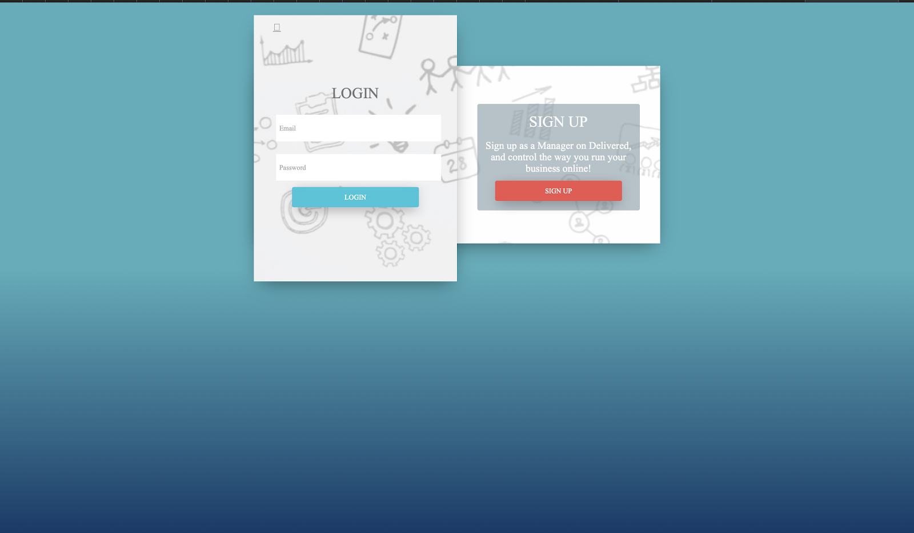

The Manager sign in and up page has the same functionalities as those of the Customer’s page. We can sign in or sign up with one click of a button. As well as save our password for the site automatically.

When you click on the login button from the Manager’s Login page it will transition to the ***Delivered* ✅ platform for Manager:**

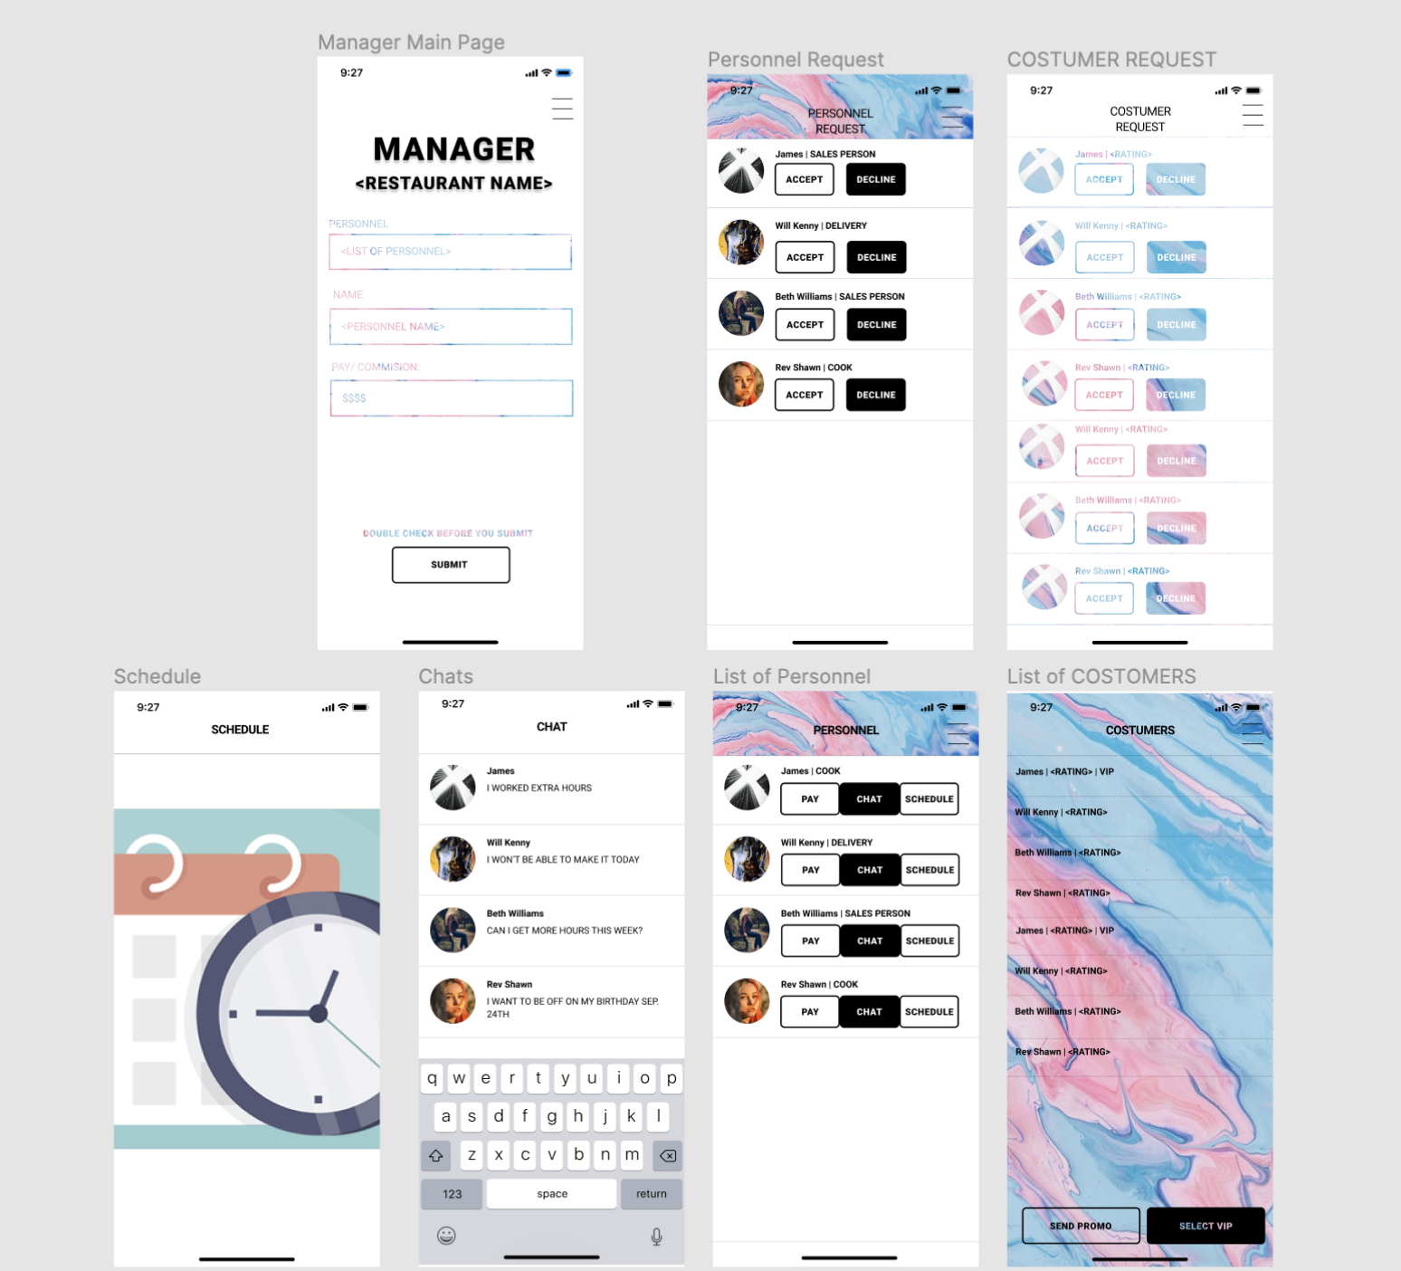

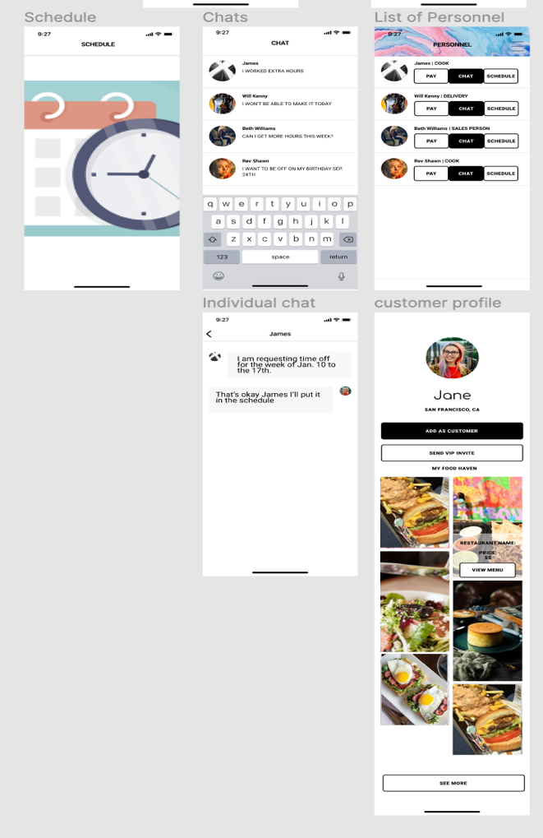

The manager can be considered the admin of the page. He or she is in charge of accepting or declining personnel, as well as customers. On our website we will have buttons that say “Accept” or “Decline” which will give the manager the power to control who has access to personnel pages and who becomes a customer or VIP. The manager is also in charge of paying/commissioning the employees, their homepage will prompt the manager to input personnel type, name, and pay/commission. We added some special features such as creating a chat (Imessage room) between the personnel and manager only. The manager is also able to access the schedules of each employee, with just a click of a button.

**Cook**:

(Sign In/ Up page)

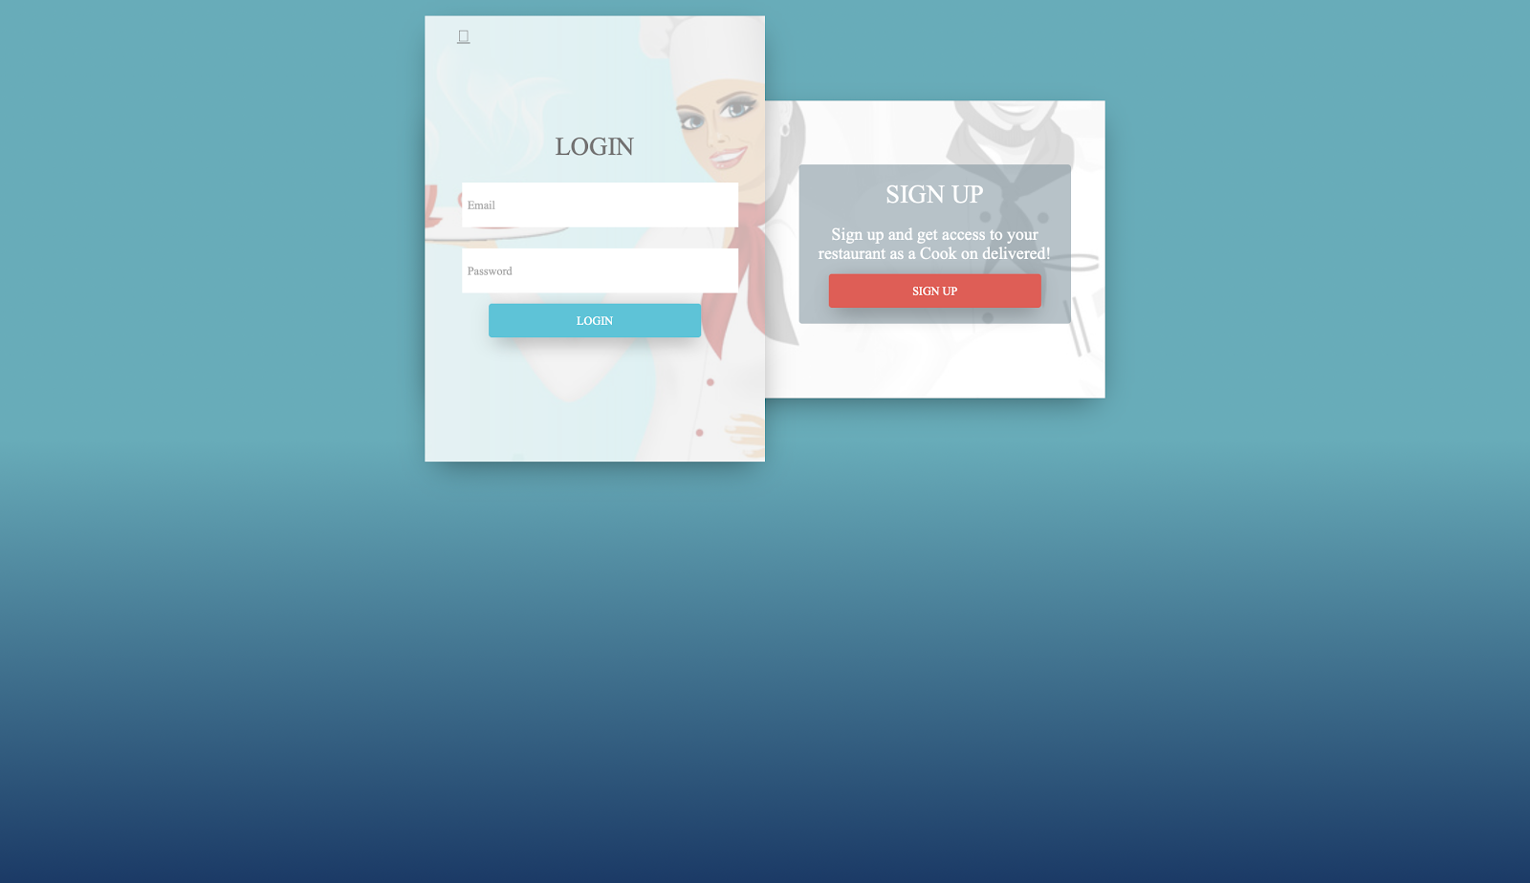

The Cook’s sign in and up page has the same functionalities as those of the Customer’s page. We can sign in or sign up with one click of a button. As well as save our password for the site automatically.

**Cook Platform Prototype:**

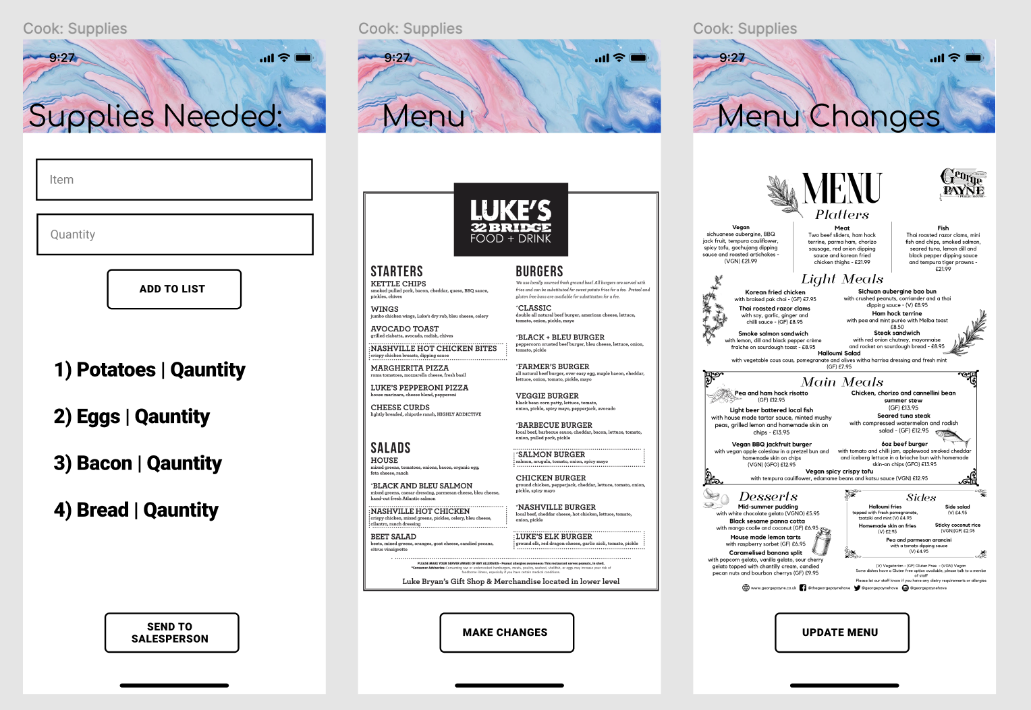

What we envisioned from the prototype was that cook would be able to make the list of supplies they need, as well as make changes to the menu. Below are the webpages, and these prototypes helped guide us on how the pages should be structured and provide for the user.

When you click on the login button from the Cook’s Login page it will transition to the

***Delivered* ✅ platform for the Cook:**

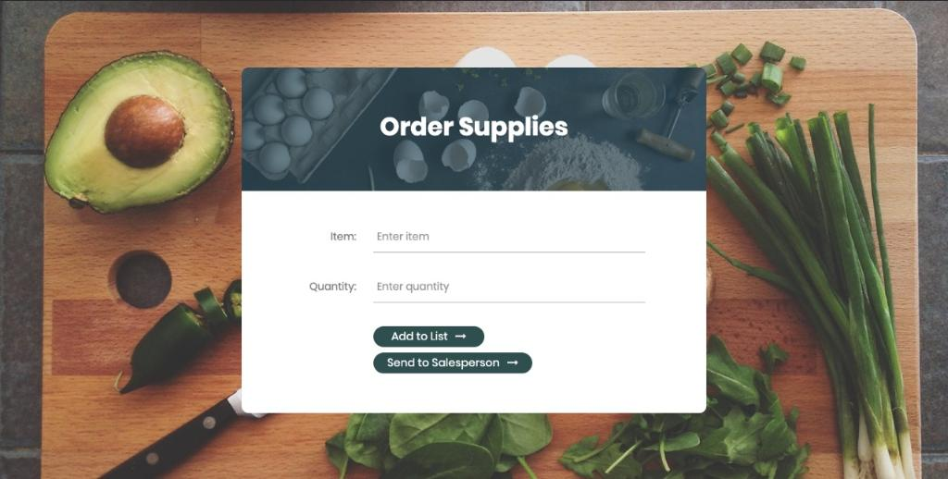

The Order Supplies page will be the first page the Cook sees after logging in. For this page we have two major functionalities the “Add to list” and “Send to Salesperson”. The cook is able to type what item and how much (quantity) of that item they may need. Order Supplies allows the cook to make a grocery list and send all the items he or she needs to that list by pressing the “Add to listen” button. The cook can also Send the item & quantity they need immediately to the salesperson to order the supplies the cook needs by pressing the “Send to Salesperson” button.

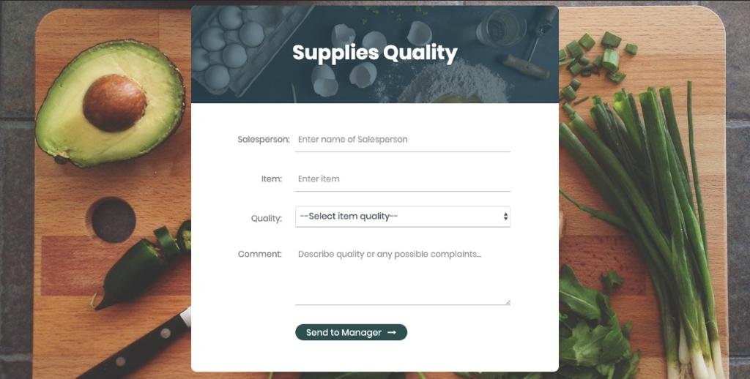

The next page the Cook can go to is Supplies Quantity. In this page the Cook can input the Salesperson, the Item that the salesperson got them, and in the quality, there is a drop down box that allows the cook choose a rating when it came to the quality of the item. And lastly the Cook can give comments to the Salesperson about the supplies they ordered. This page is the Cook’s feedback page, allowing them to have the functionality of ranking, but also typing their own opinion and feedback.

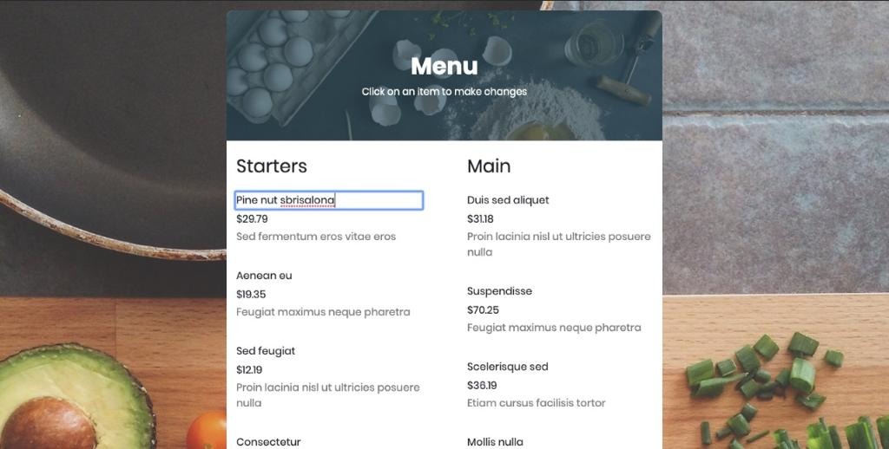

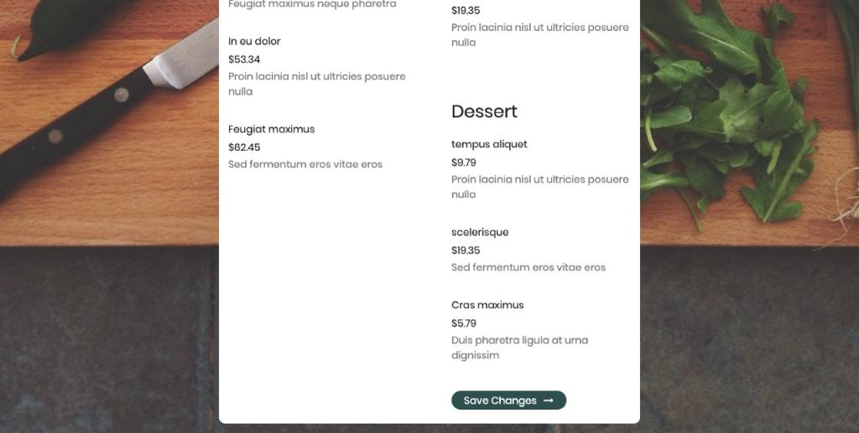

Below is the *Menu digitally*, the cooks are able to upload the Menu, make changes to the menu when it comes to items being displayed to the customer and even change the prices by doubling clicking on a specific item and then a textbox appears with the previous item, and in this the Cook can make changes to the menu. Once changes are made the cook can upload the revised menu for the restaurant on *Delivered* ✅ by pressing the button “Save Changes.”

**Delivery**:

(Sign in/ Sign Up)

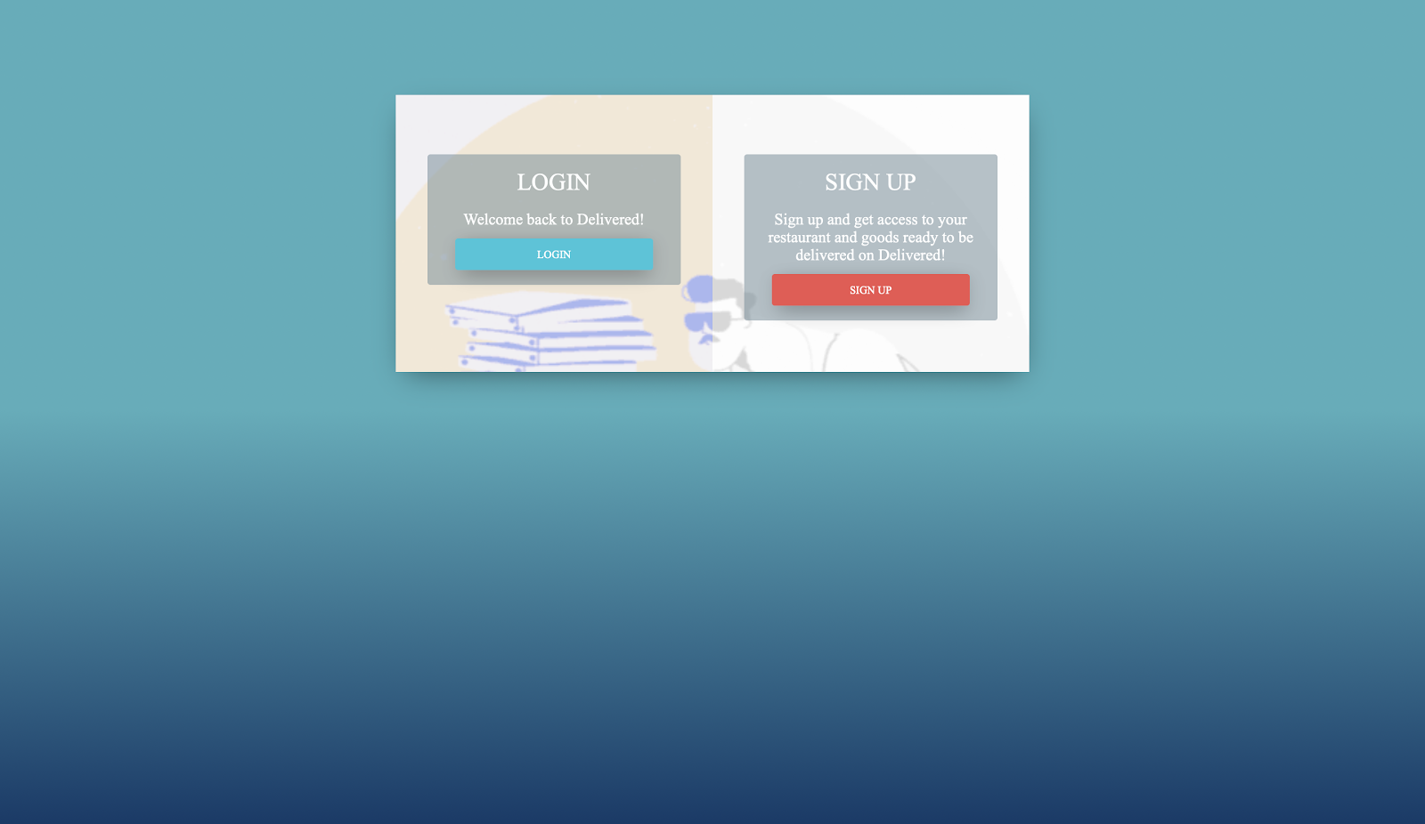

The Delivery Person’s sign in and up page has the same functionalities as those of the Customer’s page. We can sign in or sign up with one click of a button. As well as save our password for the site automatically.

**Delivery Platform Prototype:**

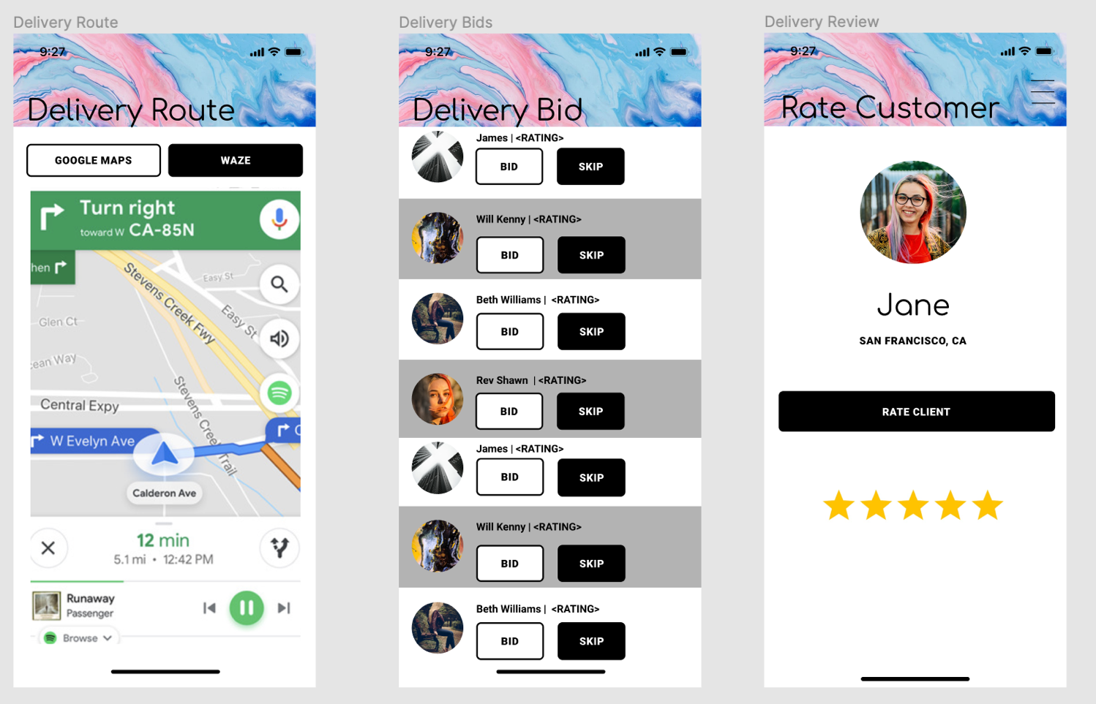

We envisioned the delivery person would be able to bid on customers and see their ratings as well, while they’re bidding. This specific user would be able to decide if they want to use google maps or waze to help them find the most optimal and time efficient route, to deliver to the customer in a speedy manner. The delivery person can also rate the costumer.

When you click on the login button from the Delivery Person’s Login page it will transition to the ***Delivered* ✅ platform for the Delivery Person:**

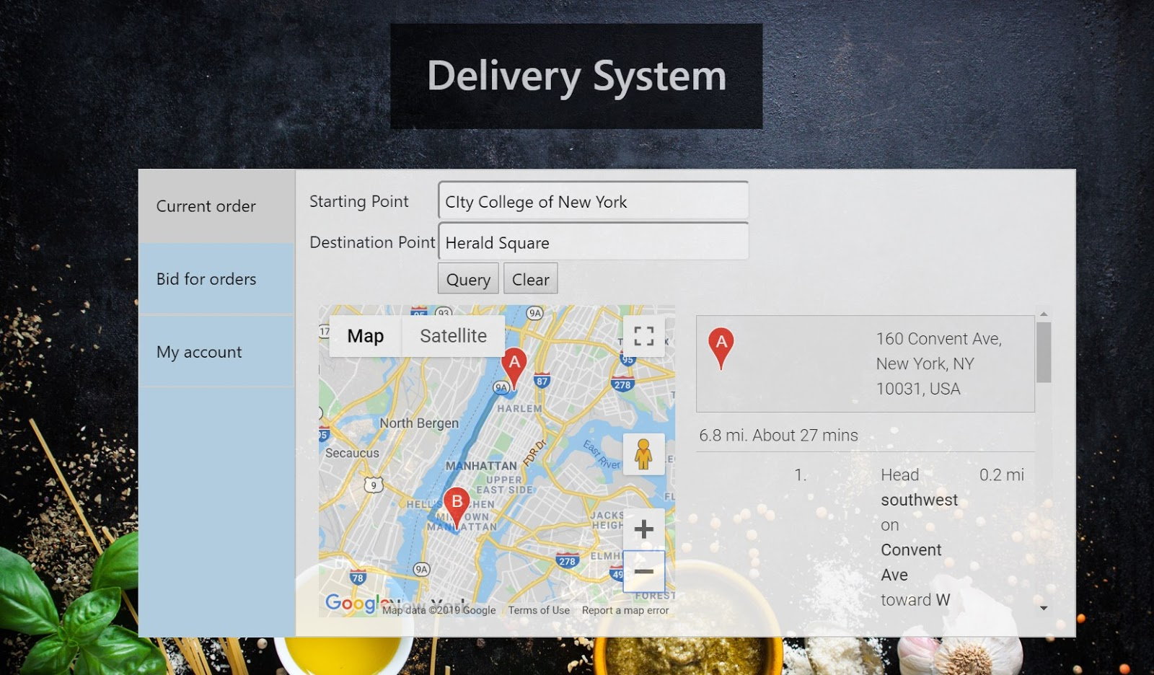

This is the first page the Delivery Person will see, showcasing the best route to deliver food to the customer. We implemented this using HTML, CSS, and JavaScript to create the page, design it and make it interactive. In order to create the map for the Delivery Person we used the Google Maps API. The user can input their Starting Point and Ending Point, and for the google map we can use geocoding to locate the points and calculate the distance, time, and fastest route for the delivery person.

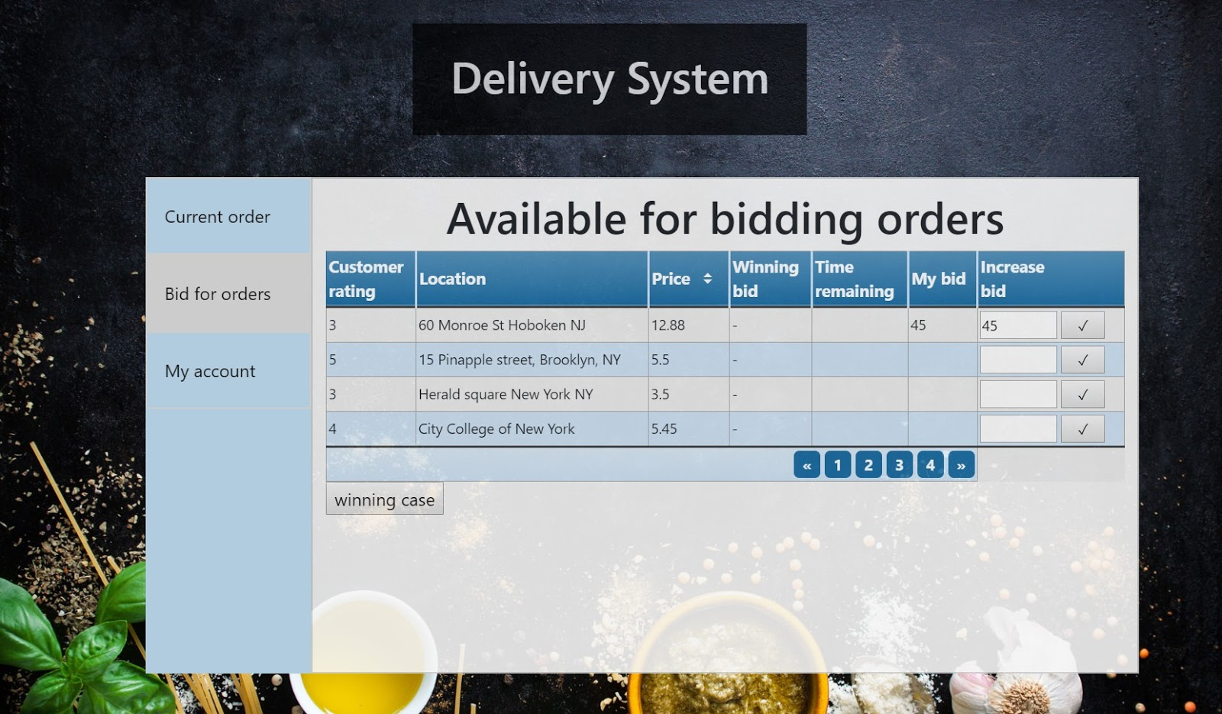

The second page is intended for bidding, the Delivery Person has to bid in order to get a customer. In this page we have a list of available for bidding orders. It will showcase in columns the “Customer rating”, “Location”, “Winning Bid”, “Time Remaining”, “My Bid”, and “Increase Bid”. All of these columns helps the Delivery Person decide how much they want to bid for a Customer based off of the Customer rating and location, the delivery person can also increase bid.

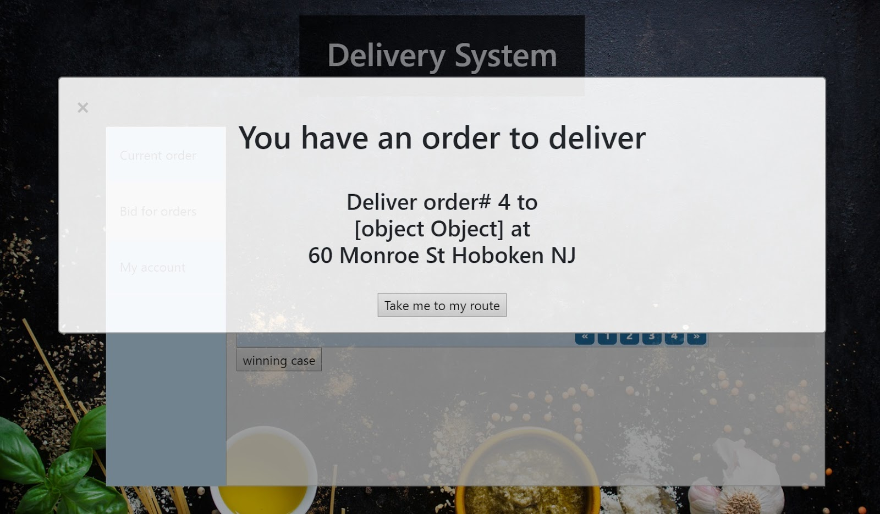

This is a pop up box that was created using JavaScript, to inform the Delivery Person that their bidding was successful, as well informing the Delivery person where and who they will be delivering the order to, the Delivery Person can transition back to the map by pressing Current Order.

**Salesperson:**

(Sign in/ Sign Out Page)

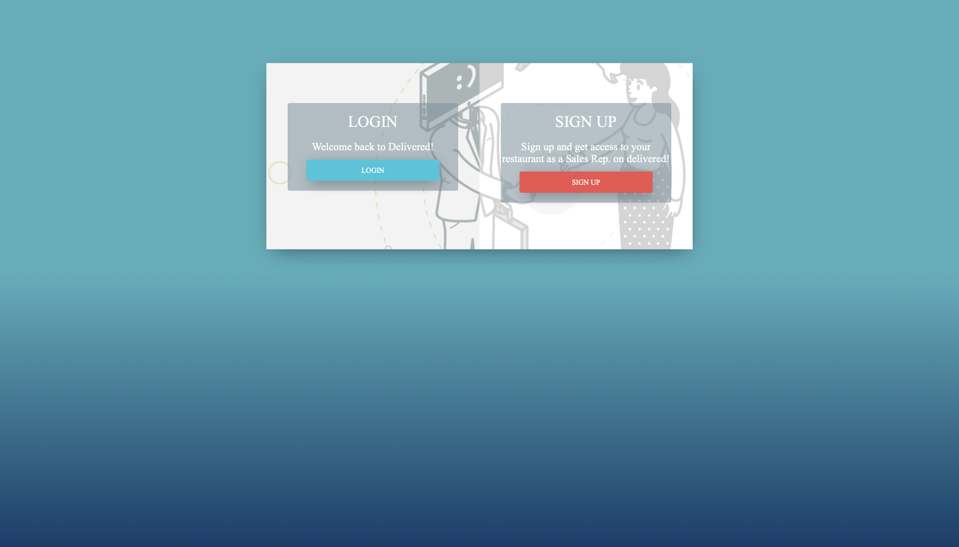

The Salesperson’s sign in and up page has the same functionalities as those of the Customer’s page. We can sign in or sign up with one click of a button. As well as save our password for the site automatically.

**Salesperson Prototype:**

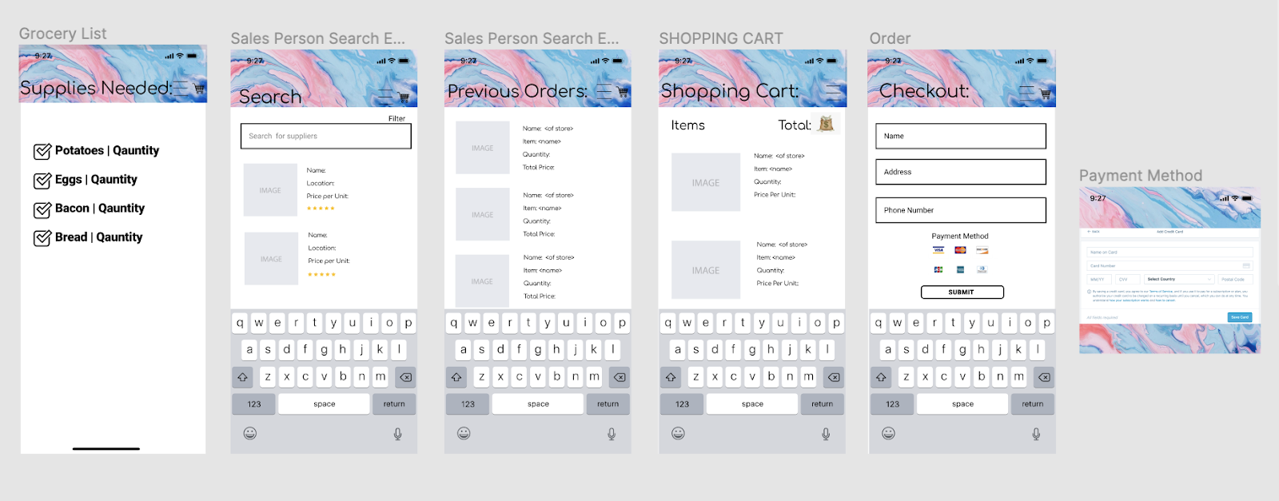

In this prototype you can see what we envision for the salesperson platform to be similar to that of online shopping, but in this case it’s shopping for food supplies. The Salesperson is able to see all the supplies the cook needs. Can view their previous supply orders, search for supplies and filter by price. And can order supplies online to reach on time for the cooks, they can also pay online at checkout.

Note*** These are all just rough drafts for the salesperson website, not all pages have been completed yet. You can reference the prototype to see what the completed platform for the Salesperson will look like.

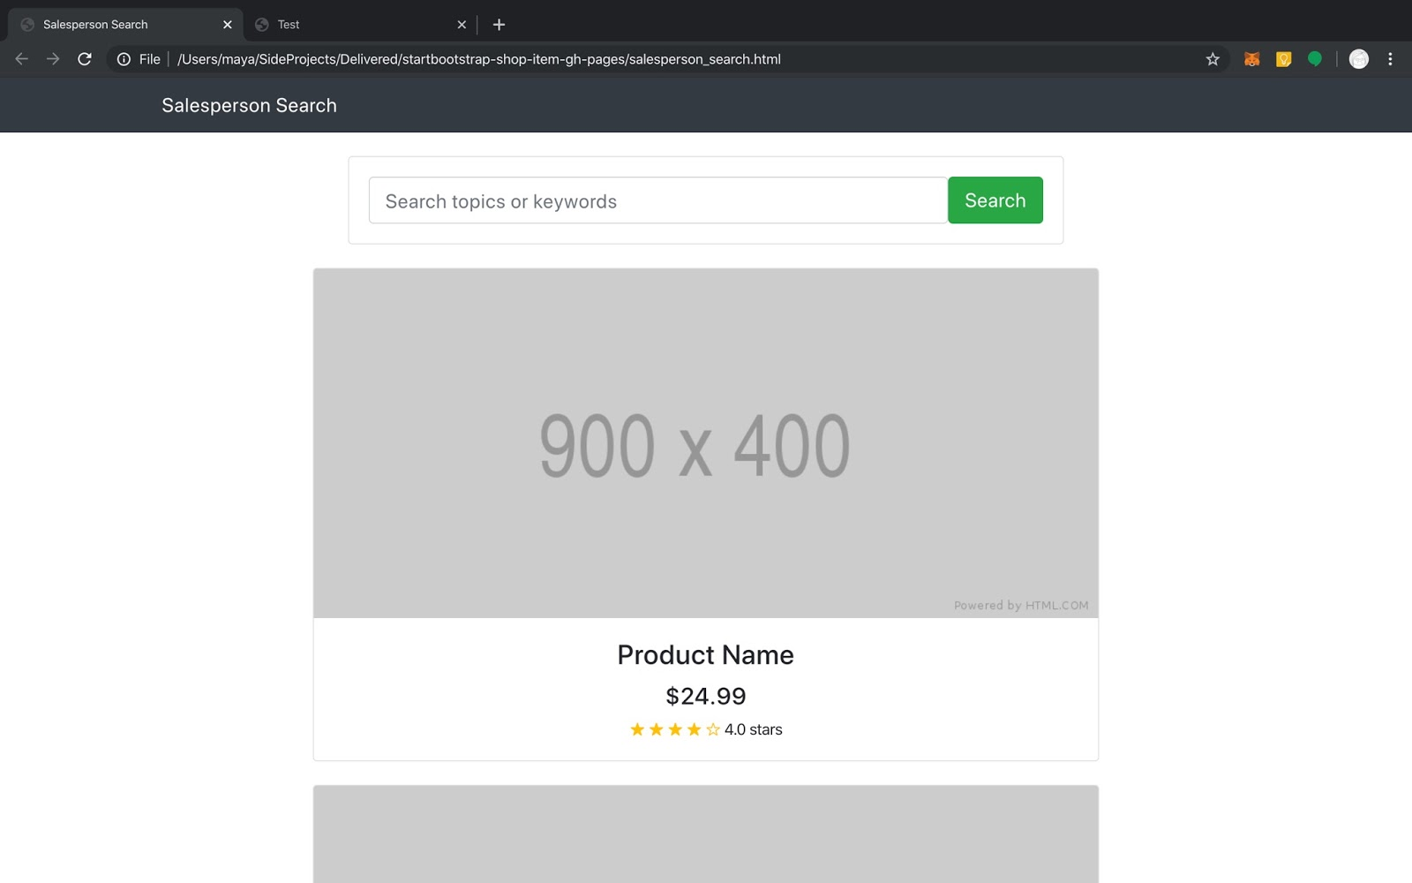

This is the first page the Salesperson will see, it will have images of items, price, and rating. The search bar is where the Salesperson can search for specific items and the list of suppliers who sell the item will appear once the user presses the “Search” button.

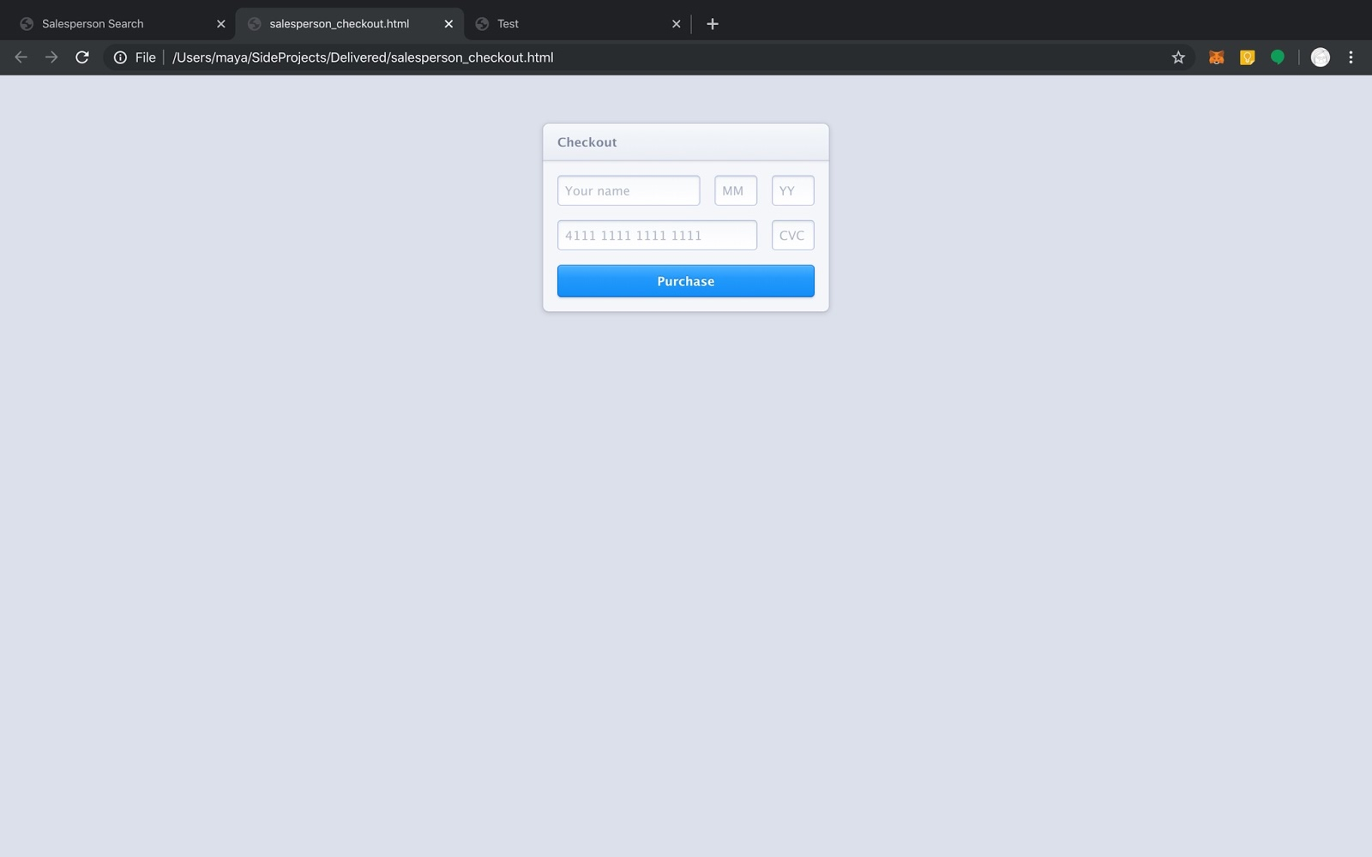

This page represents the checkout that the Salesperson would use to add their name, and credit card to pay for the supplies they are ordering. They Salesperson can input all their information by typing, and when they’re done putting in their info, they can press “Purchase” and the order would be completed.

# Meeting Minutes

# Meeting Dates on Google Hangout:

|  |  |  |
| --- | --- | --- |
| Meeting Dates: | Duration of Meeting: | Motive: |
| 10/29/19 | 2 hours | This was our first major call in which we planned out our own deadlines for the project when it came to the web pages; dividing up who will work on what and do research on certain topics. We also added tasks to our Trello, but mainly discussed Phase #1 Report. We also discussed the prototypes and how we wanted to go about the design of the project. |
| 11/23/2019 | 1 hour | We discussed who would be doing certain parts of Phase #2 Report. We also discussed our struggles with our website. One concern was how do we make all the pages cohesive, we decided to use a specific color that would tie all of our user pages together. We updated our Trello and discussed what we have done. |

**Meeting in Person:**

|  |  |  |
| --- | --- | --- |
| Meeting Dates: | Duration of Meeting: | Motive: |
| 09/26/2019 | 30 mins | To create Trello and GitHub account for *Delivered* ✅. Also decided it would be a WebApp implemented from HTML, CSS, and JavaScript. |
| 11/02/2019 | 1 hour | To Update each other on progress of Phase #1 Report and review rough draft |
| 11/26/2019 | 45 mins | To Update each other and review Phase #2 Report |

**Communication through Messages:**

|  |  |  |
| --- | --- | --- |
| Text Messages | Total Number of Text: | Motive: |
| 09/05/2019 - Present | Everyday! Therefore, over 450+ text messages. | Our main source of communication is through texting. On the chat we showcase our progress, images of our webpages, discuss who is doing what, talk about tasks we completed, our struggles, and overall, we discuss our deadlines as a group. We keep each other in the loop about any concerns and solve all the problems together as a group. |

# GitHub Repository

You can find all of our *code* (HTML, CSS, and JavaScript files) and *phase I and II report* on our GitHub: [*Delivered* ✅](https://github.com/FoodDeliveryApp/Delivered) ( <https://github.com/FoodDeliveryApp/Delivered>)